

**Sri Lanka Institute of Information Technology**[SE3030 - Software Architecture [2025/FEB]](https://courseweb.sliit.lk/course/view.php?id=6089)

**ASSIGNMENT 01**

# OSGI FRAMEWORK FOR PAINT SHOP

**Submitted by**

|  |  |  |  |
| --- | --- | --- | --- |
| **Name** | **REGISTRATION NUMBER** | **Status** | **Batch** |
| Senarathne S M A D | IT20089436 | Pro-rata | Weekend |

Git Hub Repository Link : <https://github.com/amila1998/OSGI_FrameWork-Paint-Shop>

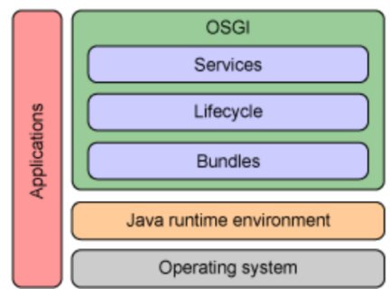

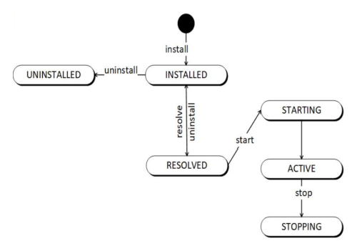

## INTRODUCTION

This system is designed to efficiently manage a paint shop. Customers can sign up and log in to browse and place orders for paints. Additionally, they have the option to choose whether their orders should be delivered.

The system also includes administrative functionality, allowing administrators to create new paints and manage delivery user accounts. Delivery users can log in to view a list of pending delivery orders and process them accordingly.

Leveraging the power of the OSGi (Open Service Gateway Initiative) framework, this system provides a modular and dynamic architecture, ensuring efficient management and seamless delivery of services.

* Admin Producer
* Customer Producer
* Delivery Producer
* Mixer (Paint) Producer
* Order Producer

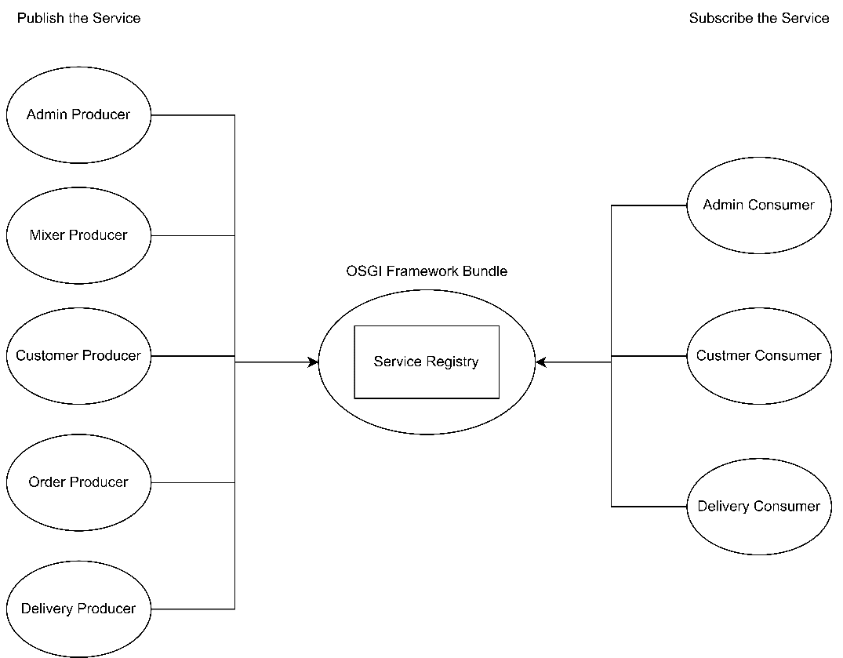

### RELATIONSHIP DIAGRAM



## WORKFLOWS

### CUSTOMER WORKFLOW



### ADMIN WORKFLOW



### DRIVER WORKFLOW



## MANIFEST IMPLEMENTATION (EXPORTED SERVICES / IMPORTED SERVICES)

### ADMIN PRODUCER

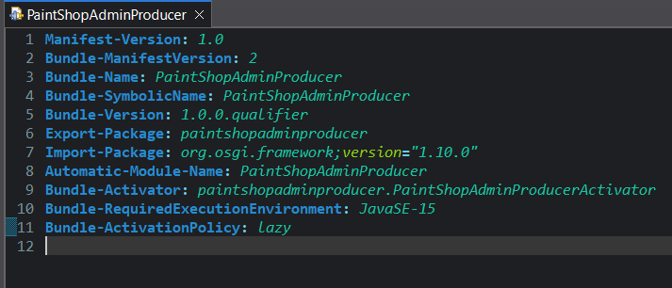

### MIXER PRODUCER

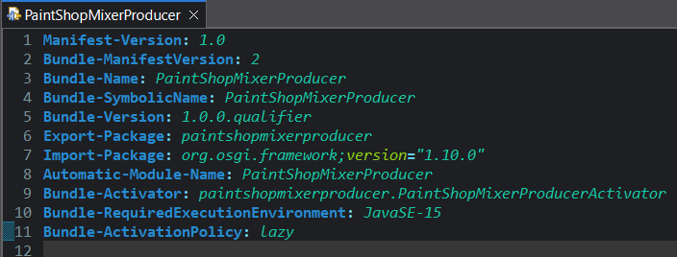

### ORDER PRODUCER

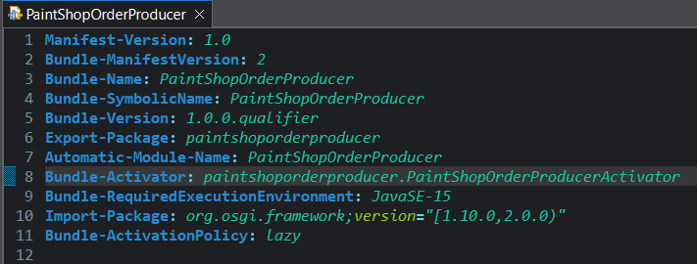

### DELIVERY PRODUCER

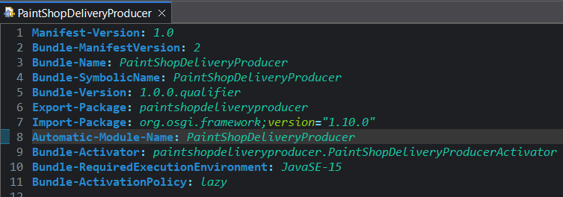

### CUSTOMER PRODUCER

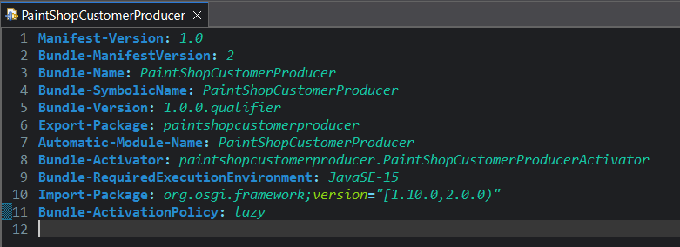

### ADMIN CONSUMER

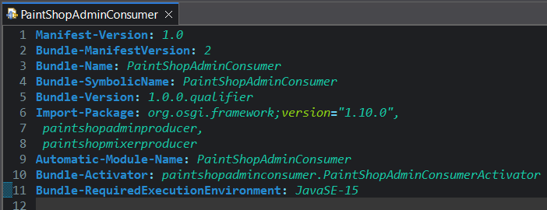

### CUSTOMER CONSUMER

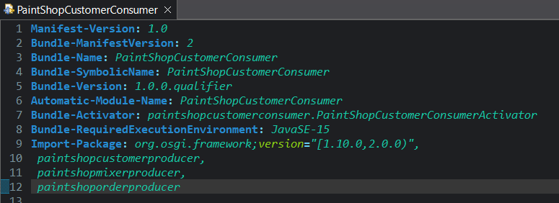

### DELIVERY CONSUMER

